**TABLE OF CONTENT**

**1.0 INTRODUCTION**

* 1. Project Background 2
  2. Problem Statement 2
  3. Objectives of the Project 3
  4. Scope of the Project 3

1.5 technologies used 4

**2.0 Webpage Design**  5-8

**3.0** **Code Sample** 9-10

**4.0** **Conclusion**

4.1 Strength of Project 11

4.2 Weakness of Project 11

4.3 Future Suggestion 11

4.4 Summary 11

**Reference** 12

# 1.0 Introduction

# Project Background

I have choose to make a webpage call HanHan Bookstore for my web developing assignment. Hanhan bookstore is a webpage that allow people to purchase book through online. This webpage not only allow customer to purchase the book but also allow the bookstore sales admin to modify the product they have in their store and also track the customer order.

# 1.2 Problem Statement

Nowadays, people are lazy to go to the store to buy the book they want. With this webpage, the customer can sit at their home and browse through the product in the shop. If without this webpage, people are unable to purchase the book whenever they want. With this webpage, it helps to improve the convenient of the people. Besides, without this webpage it will also be trouble for the shop owner because they need to keep a list of document to keep track of their customer order. With this webpage, it allow the shop owner to keep track of the customer order.

# 1.3 Objectives of the Project

The main objective of the webpage is:

1. To allow bookstore to sell their product to customer through online
2. To increase the sales of the bookstore
3. To prevent the need to go to the shop personally
4. To allow customer to access to new product faster

# 1.4 Scope of the Project

The scope of the proposed system is:

1. Registration application was provided in this system to let the users to sign up as a member
2. This system allow the customer to communicate with the admin
3. Admin and users feature is being separated:

* Admin will be able to add new product ,edit product, delete product and approve or cancel a pending order, and message a customer
* Customer are only allow to view their order, view the product ,purchase item and message admin

**1.5 technologies used**

**XAMPP**

Diagram 1.5.1 show XAMPP.XAMPP is an open source, easy to install Apache distribution which provide local Module of Apache, MySQL, FileZilla, Mercury and Tomcat (Apache Friend, 2017)

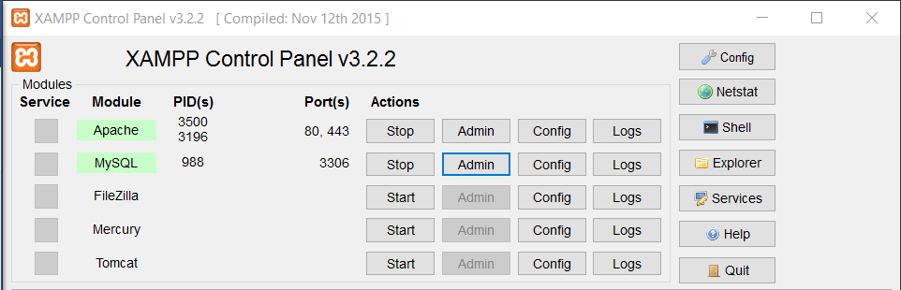

Diagram 1.5.1 XAMPP menu

**Notepad++**

Diagram 1.5.2 show Notepad++.Notepad++ is a source code editor and Notepad replacement that supports several languages. Running in the MS Windows environment, its use is governed by GPL License.

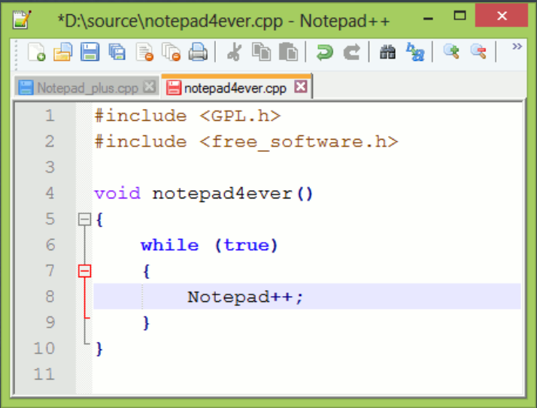

Diagram 1.5.2 Notepad++

**2.0 Webpage Design**

Webpage Name: HanHan Bookstore

Home Page

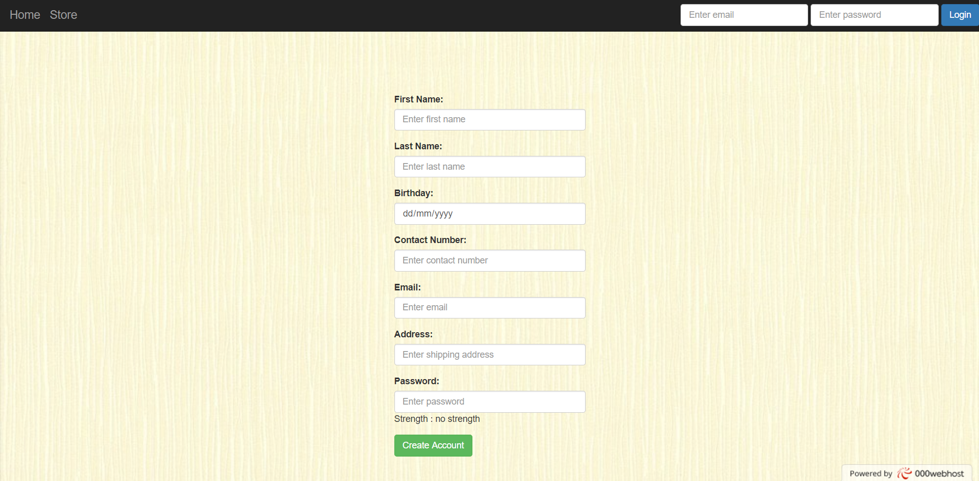

Diagram 2.0.1 Home Page

Diagram 2.0.1 show the First page of the website. User is given choice whether to **login** or **Create Account.** When creating account, if there is any invalid input, the page will pop up red message to tell the users

*Users view*

Product Page

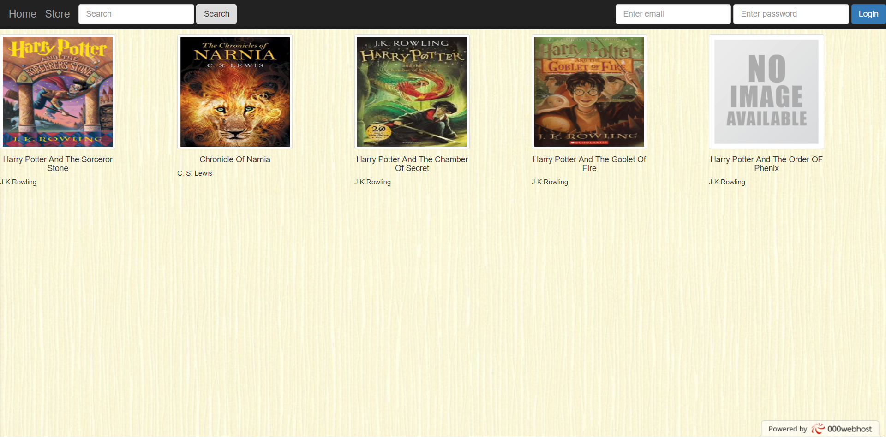

Diagram 2.0.2 Product Page

Diagram 2.0.2 show the Product Page of the website. This is where the customer views through the shop product.

Product Detail Page

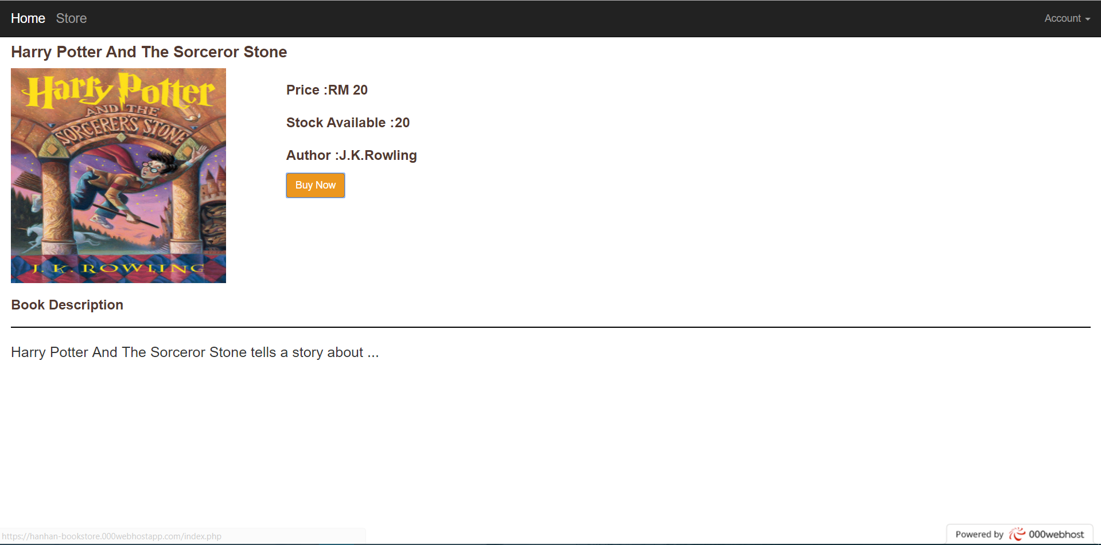

Diagram 2.0.3 Product Detail Page

Diagram 2.0.3 show the Product Detail Page of the website. This is where the customer can purchase product and check the price

Purchase status page

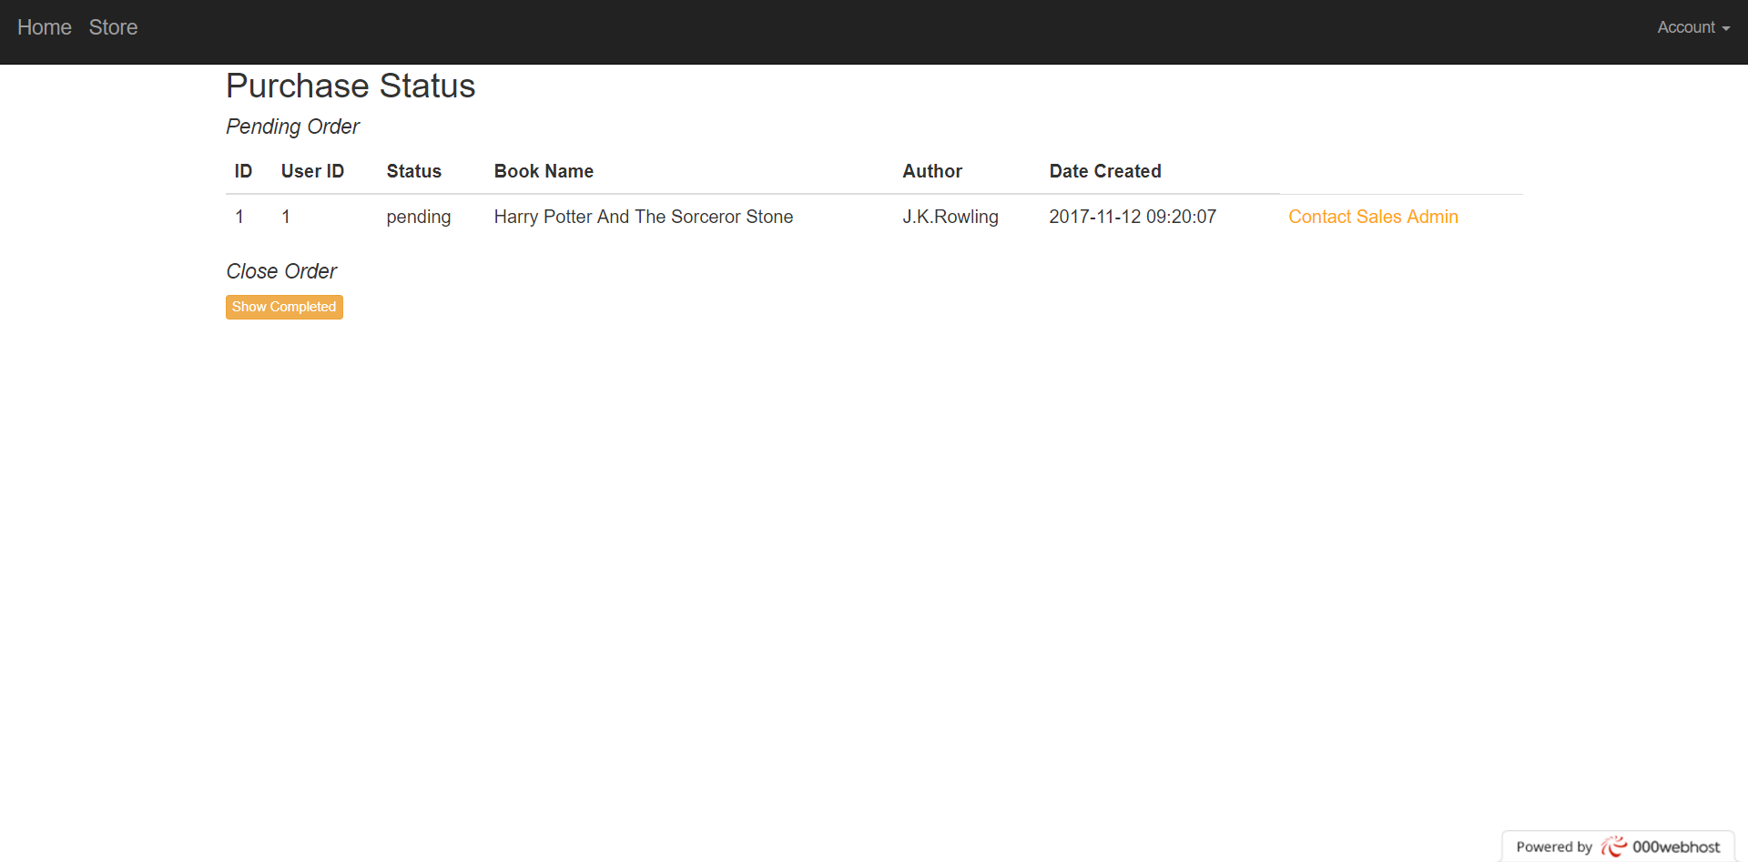

Diagram 2.0.4 Purchase status page

Diagram 2.0.4 after user click on buy now button, it will redirect to the Purchase status page. In this page, users can see the status of their purchase.

Contact sales admin page

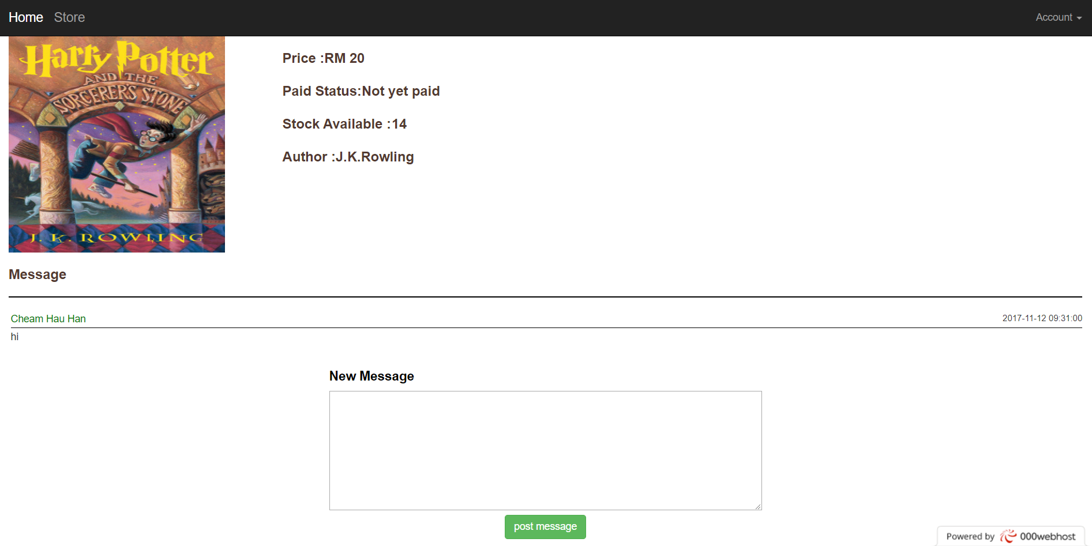

Diagram 2.0.5 Contact sales admin page

After user click on contact sales admin on Purchase status page, user will be take to Contact sales admin page as shown in Diagram 2.0.5. This is where the customer and the sales admin communicate to each other to purchase the item; for example, the admin will use this page to let the customer know which bank account they will need to bank in the money.

*Admin View*

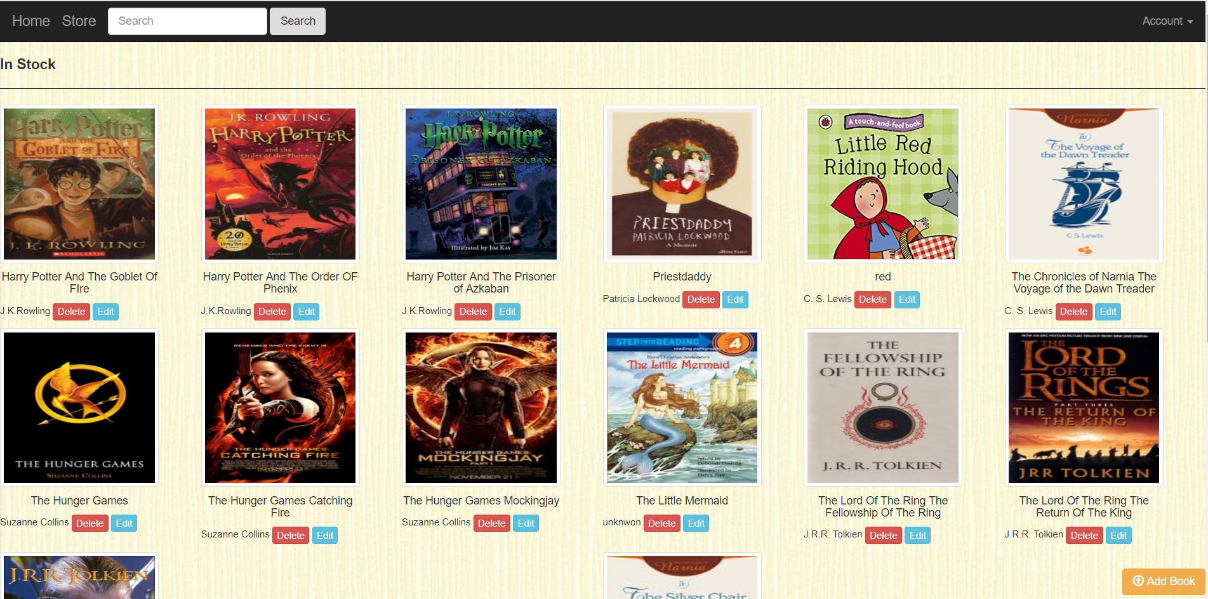

Diagram 2.0.6

When login as admin, admin will have more access to the webpage, for example, admin are allow editing, deleting and adding a new book to the store as shown in Diagram 2.0.6

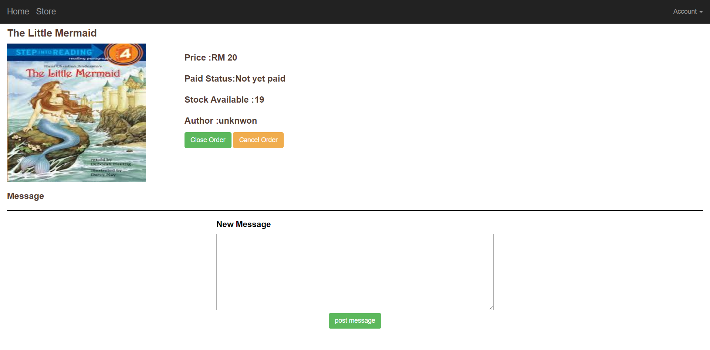

Diagram 2.0.7

Admin can also close or cancel an order as shown in Diagram 2.0.7

3.0 Code sample

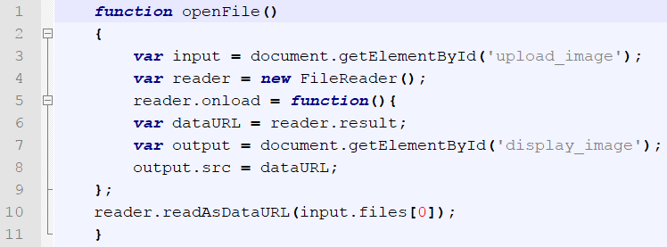

Diagram 3.0.1

This JavaScript code allow the webpage to direct display the image whenever users choosing a file to upload as shown in Diagram 3.0.1 above



Diagram 3.0.2

The on error command inside the image tag will find the default image inside the folder whenever the page cannot find the correct image as shown in Diagram 3.0.2 above

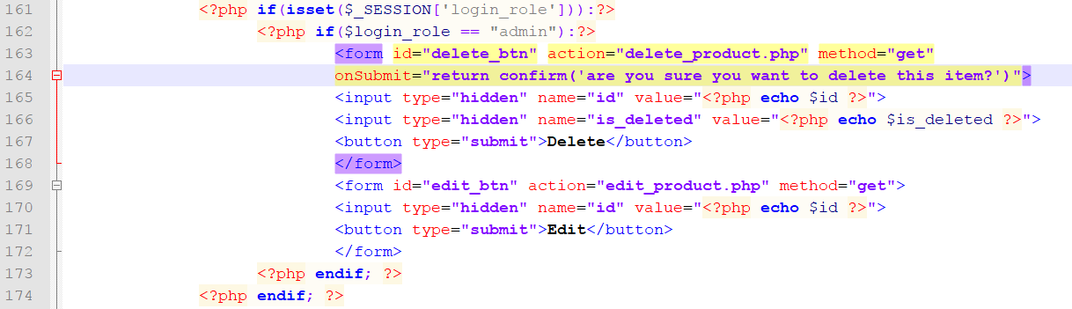

Diagram 3.0.2

Line 161 show in diagram 3.0.2 above will check whether the login_role has been session, if it is session, check whether the login_role is admin, if it is, run the code inside the if. With this way, I am able to allow the webpage to determine whether the delete and edit button need to show to the users. For example, if the users is admin, it will show the edit and delete button, if it is the customer, it will not show.

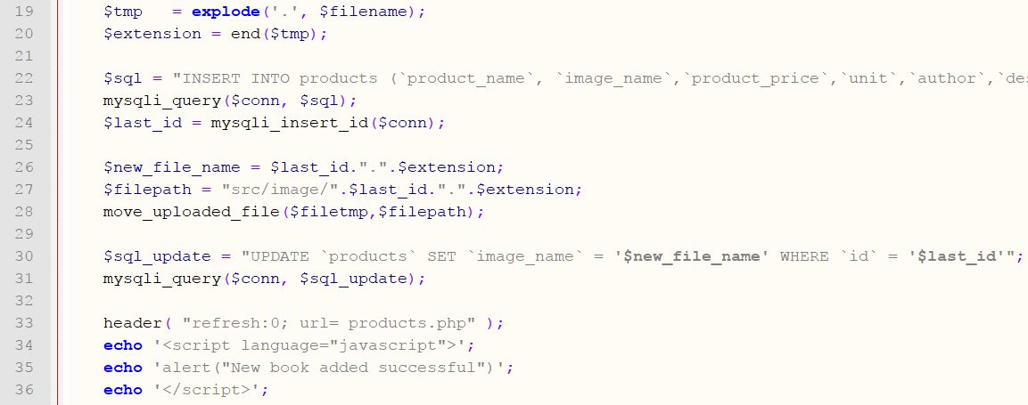

Diagram 3.0.3

In Diagram 3.0.2 show that ,to avoid the possibility for the new added image to overwrite the current image from different product when admin upload the image because of the same name, at line 19,I use php explode function to separate the image file name and the extension and at line 20,I use php end function to get the extension and store into $extension. In line 24 I get the id of the product and store into $last_id.After that I combine the $last_id and the $extension to make a new image name.Therefore,the image name will become unique and no longer has the risk to be overridden.

**4. 0 Conclusion**

**4.1 Strength of Project**

There are several strengths of this system, one of them is it is flexible. It allow admin and customer have different view. For example, admin are allow to add in new, edit, or delete the current product and the customer are not allow to edit, delete and add product. Besides, the webpage also allow the admin to keep track of the customer order.

**4.2 Weakness of Project**

Other than strength, there is also some weakness in this webpage. One of them is this webpage lack of the function of notification. When there are new message post, the webpage will not automatically notified the users. Besides, each product are only allow to have one image to show to the customer. Another weakness of this webpage is that it only work locally.

**4.3 Future Suggestions**

In the future, more feature will be adding into this system. Besides, in the future, this system should be have add in more feature. For example, rating system will also be one of the feature that provide for the customer to give a review to the bookstore. Besides, in the future, I would also like to add a notification feature to alert the admin and customer whenever a new message is post. Besides, it possible, I plan to move the webpage from local to the server.

**4.4 Summary**

In the end of this project, I am able to make the system much better than what I expected. For example, in the beginning, I did not plan to made a webpage that allow the admin to modified the data.However,in the end I manage to made it.

**Reference**

Apache Friend, 2017, Xampp, retrieved from <https://www.apachefriends.org/about.html>

Notepad++, 2017, Notepad++, retrieved from <https://notepad-plus-plus.org/>